Experiment no. 1

Aim: Demonstration Steps involved in EDA

Tools: Google Colab, Kaggle

Theory: Exploratory Data Analysis (EDA) is a systematic approach used to understand, summarize, and analyze datasets before applying advanced statistical or machine learning techniques. The main objective of EDA is to gain insights into the data by examining its structure, identifying patterns, detecting missing values, and understanding relationships between variables through statistical measures and visualizations.
In this experiment, EDA is performed on a state-wise inflation index dataset of India, which contains information such as sector, year, and inflation index values for different Indian states and union territories. The dataset includes both categorical variables (Sector, Name) and numerical variables (Year and state-wise inflation indices).
The experiment begins by studying the data structure, which includes determining the number of rows and columns, identifying data types, and understanding the overall format of the dataset. This step ensures familiarity with the dataset and helps in selecting appropriate analysis methods.
Next, a statistical summary is generated to compute key descriptive statistics such as mean, median, minimum, maximum, and standard deviation for numerical columns, and frequency counts for categorical columns. This helps in understanding the central tendency and dispersion of the inflation data.
Univariate analysis is then performed to study individual variables separately using techniques such as histograms, bar charts, and box plots. This analysis helps in understanding the distribution and variability of inflation values for each state and across years.
Bivariate analysis is carried out to examine relationships between two variables, such as year-wise inflation changes for a particular state or comparison of inflation between two states. Scatter plots and box plots are used to identify trends, correlations, and variations.
Multivariate analysis is performed to analyze relationships among multiple state-wise inflation variables simultaneously. Correlation matrices and heatmaps are used to identify similarities and dependencies between inflation trends of different states.
The experiment also includes missing value analysis, where null or missing values are identified and quantified. This step is important to ensure data quality and reliability of the analysis.
Thus, through systematic EDA techniques and visualizations, meaningful insights are extracted from the inflation dataset, enabling better understanding and interpretation of state-wise inflation trends in India.

Code and Output:

Step 1: Import Libraries

import numpy as np
import pandas as pd
import matplotlib.pyplot as plt
import seaborn as sns

Step 2: Add Data Set

df = pd.read_csv('/content/Statewise_General_Index_Upto_Feb24.csv')

Step 3: Find Data structure

# Shape of dataset
df.shape
# Column names
df.columns
# Data types and non-null counts
df.info()
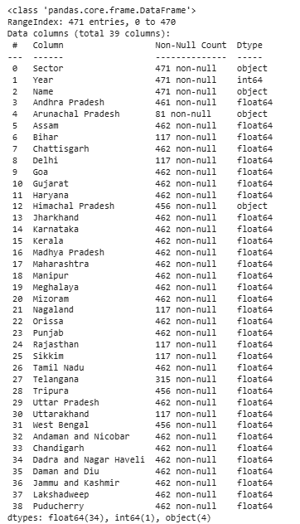

Step 4: Statistical Summary

df.describe()
df['Andhra Pradesh'].describe()
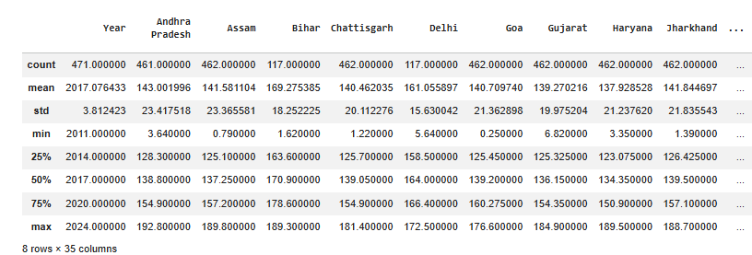
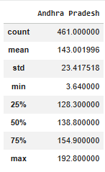

Step 5: Univariate Data
df['Andhra Pradesh'].hist(bins=15)
plt.show()

sns.boxplot(x=df['Andhra Pradesh'])
plt.show()
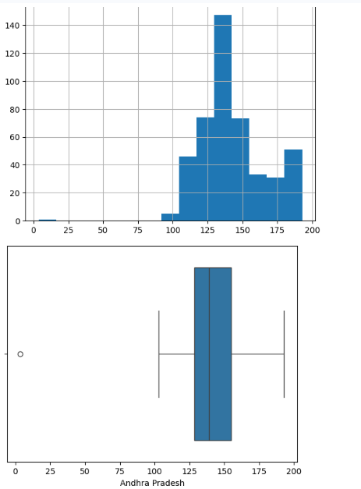

Step 6: Bivariate data
sns.scatterplot(x='Year', y='Maharashtra', data=df)
plt.show()

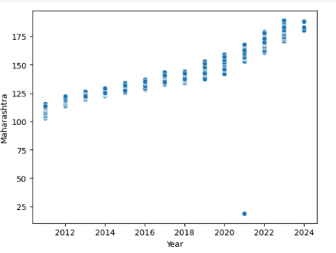

Step 7: Multivariate Data
selected_states = ['Andhra Pradesh','Gujarat','Maharashtra','Tamil Nadu','West Bengal']
filtered = df_melted[df_melted['State'].isin(selected_states)]
plt.figure(figsize=(12,6))
sns.lineplot(
data=filtered,
x='Year',
y='Inflation',
hue='State'
)
plt.title('Inflation Trend of Selected States')
plt.show()
selected_states = ['Andhra Pradesh','Gujarat','Maharashtra','Tamil Nadu','West Bengal']
filtered = df_melted[df_melted['State'].isin(selected_states)]
plt.figure(figsize=(12,6))
sns.lineplot(
data=filtered,
x='Year',
y='Inflation',
hue='State'
)
plt.title('Inflation Trend of Selected States')
plt.show()
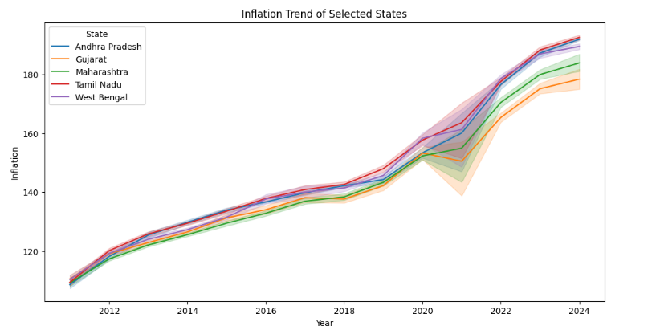

Conclusion:

For Faculty Use:
Correction Parameters | Formative Assessment [40%] | Timely completion of Practical [ 40%] | Attendance / Learning Attitude [20%]

